**EXPERIMENT NO. 3**

**AIM:** Study and familiarization with various network devices.

**MATERIAL AND REQUIREMENTS**:

* Routers
* Switches
* Hubs
* Wireless Access Points (APs)
* Firewalls
* Computers or laptops for configuration
* Network cables

**INTRODUCTION**:

In modern networking, various devices are crucial for establishing and maintaining network connections. Understanding these devices and their functions is fundamental to network management and troubleshooting. This practical aims to introduce students to the key network devices.

**PROCEDURE:**

**Part 1:** Introduction and Theory

**Overview of Network Devices:**

Begin with an explanation of the various network devices you will be covering, such as routers, switches, hubs, access points, and firewalls.

Briefly describe the primary functions and roles these devices play in computer networks.

* **Repeater:**

Repeaters are network devices operating at [physical layer](https://www.tutorialspoint.com/data_communication_computer_network/physical_layer_introduction.htm) of the [OSI model](https://www.tutorialspoint.com/The-OSI-Reference-Model) that amplify or regenerate an incoming signal before retransmitting it. They are incorporated in networks to expand its coverage area. They are also known as signal boosters

. 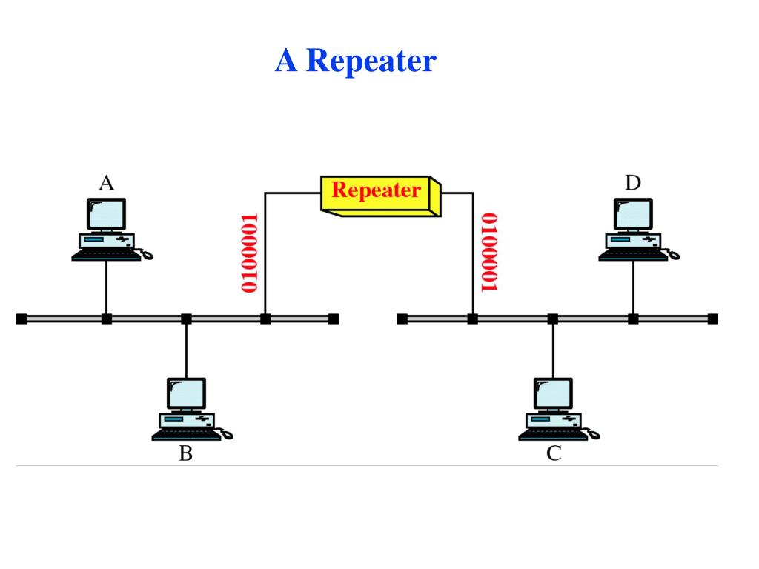

* **Router:**

A router is an electronic device that interconnects two or more computer networks, and selectively interchanges packets of data between them. Each data packet contains address information that router can use to determine if the source and destination are on the same network, or if the data packet must be transferred from one network to another.

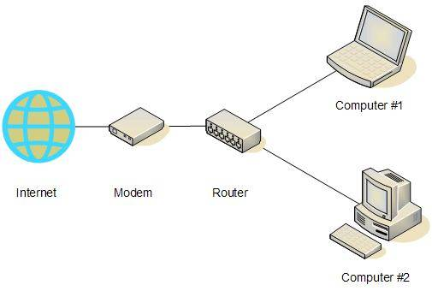

**Switch:**

A network switch or switching hub is a computer networking device that connects network segments. The term commonly refers to Network Bridge that processes and routes data at the data link layer (layer2) of the OSI model. Switches that additionally process data at the network layer (layer3 and above) are often referred to as Layer 3 switches or multilayer switches.

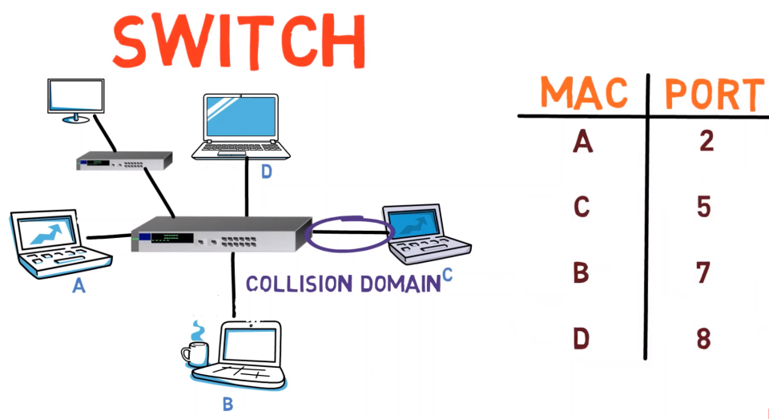

* **Hub**:

An Ethernet hub, active hub, network hub, repeater hub or concentrator is a device for connecting multiple twisted pair or fiber optic Ethernet devices together and making them a single network segment. Hubs work at the physical layer (layer 1) of the OSI model. The device is a form of multiport repeater.

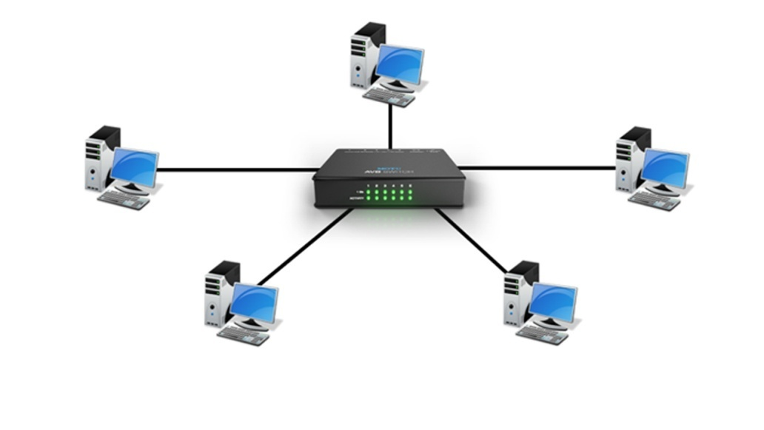

* **Bridge:**

A network bridge connects multiple network segments at the data link layer (Layer2) of the OSI model. In Ethernet networks, the term bridge formally means a device that behaves according to IEEE 302.1 D standards. A bridge and switch are very much alike; a switch being a bridge with numerous ports

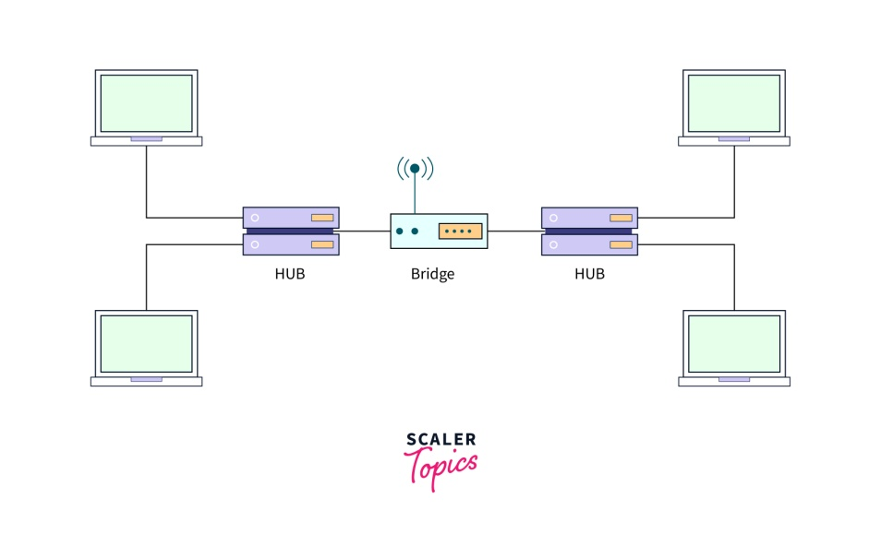

* .**Firewall:**

Introduce firewalls as devices designed to protect a network from unauthorized access and cyber threats.Explain their security functions, including packet filtering and stateful inspection.

**Part 2:** Hands-On Familiarization

**Physical Examination:**

* Provide physical access to the network devices.
* Encourage students to observe the device's physical characteristics, including ports, LEDs, and any labels.

**Web-Based Configuration** :

* If possible, access the web-based configuration interfaces of routers, switches, and wireless access points.
* Show how to log in and navigate the interface.

**Port Identification**:

* Identify and label the various ports on each device, including LAN, WAN, and console ports.